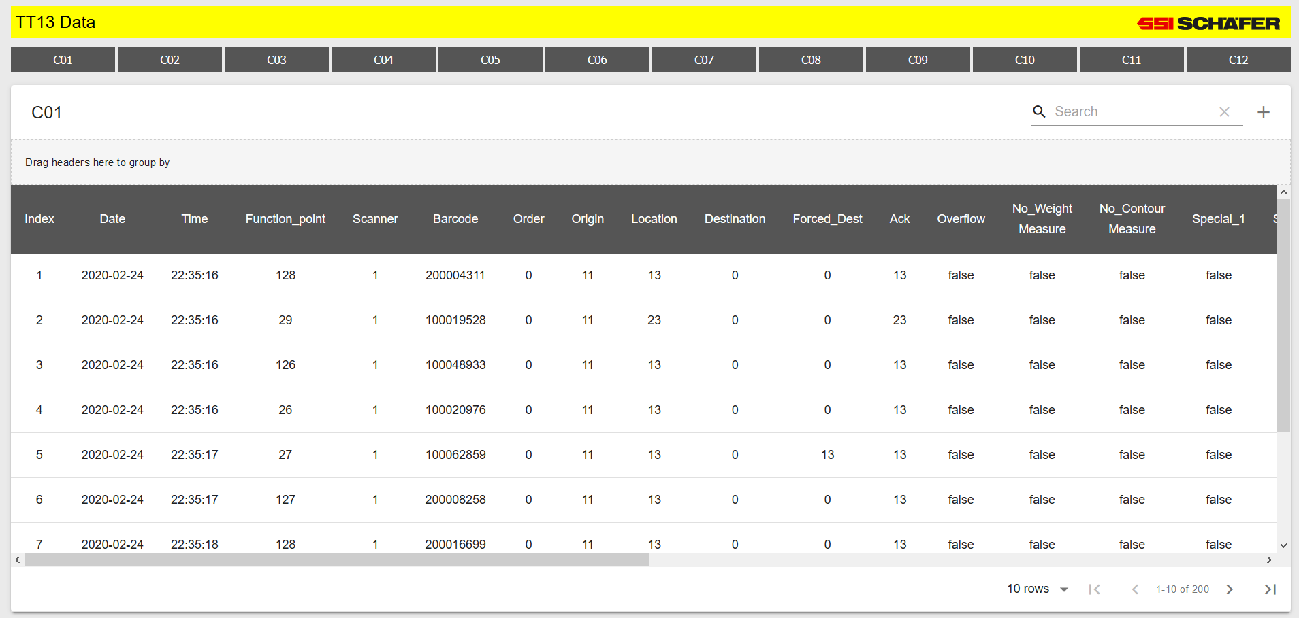

* Connect to the PLC network via Lowe’s Guest & vpn or ssiplc.
* Click button labeled C01 – C12 to read from each area.
* Search for text within the table, don’t have to specify a column. Will automatically return matching results.
* Click to toggle between “condensed” & “extended” column view.
* Navigation
  + Default only displays 10 rows, you can select 5, 10, or 20 rows.
  + Use arrows to navigate between pages.
* Drag & drop column headers to group data fields together. Click the fields to change between ascending and descending order.

